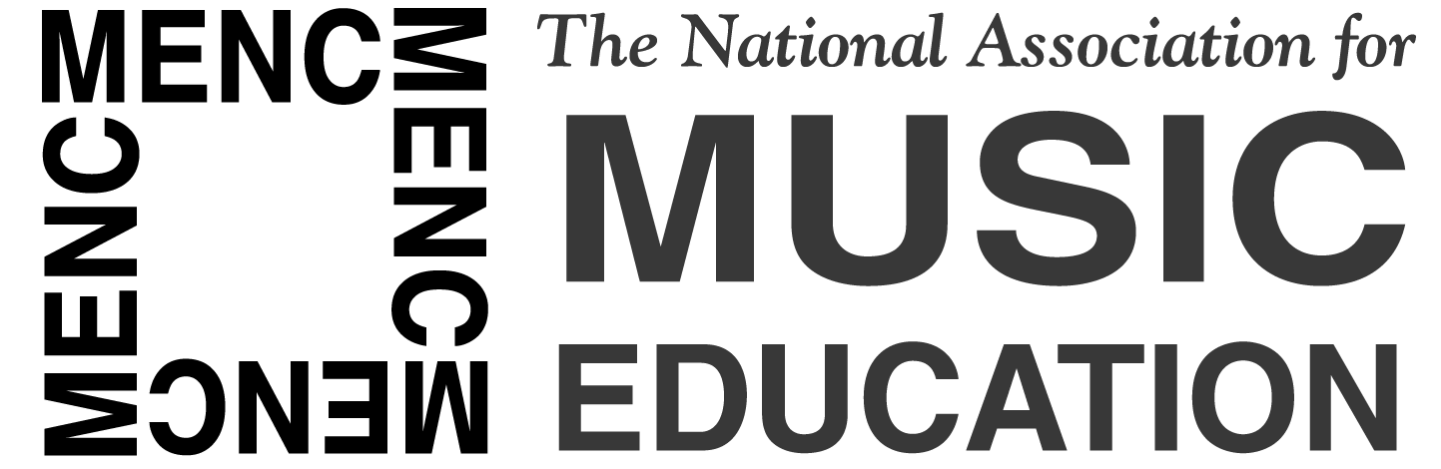

NEWS RELEASE
Contact:
Elizabeth Lasko, MENC Director of Public Relations
ElizabethL@menc.org or (703) 860-4000
Beth DeHoff, MFA Community Relations Manager
beth.d@musicforall.org or (317)-524-6209

MENC and Music for All Form Strategic Partnership

RESTON, VA (May 20, 2010) – Music for All and MENC: The National Association for Music Education, two of the world’s largest arts education organizations, have formed an alliance for educational and professional development. As strategic partners, Music for All (MFA) and MENC will work together on programs of national significance to music education, including new and existing programs of both organizations.
As part of the agreement, MENC is designated an official educational partner of Music for All, and MFA is designated an official strategic partner of MENC.
“Our nation, and music education, is in a time of change, and we must advocate for music education through imagination and creativity,” said Barbara Geer, president of MENC. “It is important to remember that education without music shortchanges our children and their futures, but education with music offers many exciting possibilities. As MENC and MFA work together, we will create an emphasis on achievement in our society as well as promote positive standards in music education. This joint effort will highlight what is essential for music education in the 21st century.”
“This strategic relationship with MENC will create opportunities that will be of benefit to the entire field of music education,” said Scott McCormick, President and CEO of Music for All. “We look forward to making exciting announcements about teacher training initiatives that will result from our collaboration with MENC and that will impact the 2011 Music Education Week in Washington DC, as well as cooperative programming for our national honor ensembles. Through this strategic relationship, we look forward to standing with MENC to focus on the music teachers and student musicians we both serve, through programming as well as continued advocacy for the importance of music and arts education as a vital component of a complete education for our nation’s young people.”
-more-
Music for All fulfills its mission to create, provide and expand positively life-changing experiences through music for all by uniquely combining regional and national music-event programming with awareness campaigns and advocacy aimed at expanding access to music in schools and communities. A 501(c)(3) not-for-profit educational organization, MFA’s programs include 25-plus annual events with over 1.25 million alumni, including the Bands of America Grand National marching band championships, Regional marching band championships across the country, the Music for All National Festival and the Music for All Summer Symposium. Music for All reaches more than 500,000 young musicians, their families and teachers, and spectators through its programs, Web site (musicforall.org) and online community at my.musicforall.org, email and print publications. Follow Music for All on Facebook (facebook.com/musicforallnetwork).
MENC (www.menc.org) marked its centennial in 2007 as the only association that addresses all aspects of music education. Through membership of more than 75,000 active, retired, and preservice music teachers, and with 60,000 honor students and supporters, MENC serves millions of students nationwide through activities at all teaching levels, from preschool to graduate school. MENC's mission is to advance music education by encouraging the study and making of music by all. Since 1907, MENC has worked to ensure that every student has access to a well-balanced, comprehensive, and high-quality program of music instruction taught by qualified teachers. MENC's activities and resources have been largely responsible for the establishment of music education as a profession, for the promotion and guidance of music study as an integral part of the school curriculum, and for the development of the National Standards for Arts Education. MENC is located at the National Center for Music Education in Reston, VA. Follow MENC on Twitter (twitter.com/menc) and on Facebook (facebook.com/menc.org).

###

PHOTO ATTACHED.

- Photo caption: L. Scott McCormick, President of Music for All, Michael Butera, MENC Executive Director, Tim Lautzenheiser, President of Attitude Concepts for Tomorrow, Larry Livingston, Director of Educational Initiatives for Guitar Center, at a NAMM reception that was part of NAMM's annual music education advocacy event in Washington D.C.

