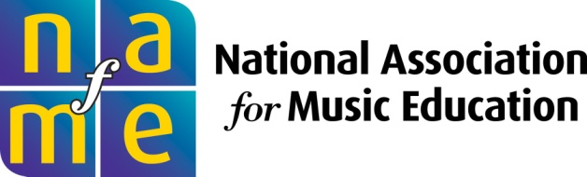
PRESS RELEASE
For Immediate Release
Contact: Elizabeth Lasko at NAfME
ElizabethL@nafme.org or (703) 860-4000

Kansas Band Director Daniel Kirk is Recipient of 2012 George N. Parks Award from the National Association for Music Education and Music for All

RESTON, VA (October 10, 2012) –The National Association for Music Education announced that Daniel Kirk, Director of Bands ad Blue Valley West High School in Overland Park, Kansas, is the recipient of the 2012 George N. Parks Award for Leadership in Music Education. He will receive the award at the Bands of America Grand National Championships in Indianapolis on Saturday, November 10, 2012.
Developed by NAfME and Music for All, the award is named for George N. Parks (1953–2010), director of the University of Massachusetts Minuteman Marching Band at the University of Massachusetts Amherst from 1977 until his death. Considered a national authority on drum majoring, he led the George N. Parks Drum Major Academy, a summer workshop program for high school drum majors.
“The George N. Parks Award honors an exemplary music educator who embodies the characteristics and leadership that Mr. Parks showed his students every day,” said Michael A. Butera, executive director of NAfME. “The recipient must have a collaborative spirit, dedication to knowing the students as people, perseverance and enthusiasm, and an ability to instill qualities in students beyond the musical. We are greatly pleased to present Daniel Kirk with this year’s honor.”

A member of NAfME and the Kansas Music Educators Association, Daniel Kirk has grown his program by nearly 30% over the last two years, and is described as incredibly dedicated to his students. His teaching responsibilities include the Symphonic Wind Ensemble, Jazz Ensemble, Honors Music Theory, and Music
theory. He administers and coordinates all aspects and staff members of the Red and Silver Brigade Marching Band. He assists with Concert Band and Freshmen Band. He is a graduate of Missouri Western State University with a B.S.E. in Instrumental Music Education with a Piano Performance Emphasis, and attended conducting symposiums and institutes coached by Mallory Thompson, Craig Kirchhoff, Steve Davis, Eugene Corporon, James Jordan, Michael Haithcock, and William Wakefield. His professional memberships include KMEA, MTNA, NAfME, MMTA, Alpha Chi Honors Society, and Kappa Delta Pi.

For more information, visit www.nafme.org.

###

National Association for Music Education, among the world's largest arts education organizations, marked its centennial in 2007 as the only association that addresses all aspects of music education. Through membership of more than 75,000 active, retired, and pre-service music teachers, and with 60,000 honor students and supporters, NAfME serves millions of students nationwide through activities at all teaching levels, from preschool to graduate school. NAfME’s mission is to advance music education by encouraging the study and making of music by all. Since 1907, NAfME has worked to ensure that every student has access to a well-balanced, comprehensive, and high-quality program of music instruction taught by qualified teachers. NAfME activities and resources have been largely responsible for the establishment of music education as a profession, for the promotion and guidance of music study as an integral part of the school curriculum, and for the development of the National Standards for Arts Education.

###

Follow NAfME on Twitter (twitter.com/nafme) and on Facebook (facebook.com/nafme).

