Music for All Kicks off Bands of America Tour
Tour includes the largest number of regional events ever

INDIANAPOLIS – Music for All is kicking off its 48th marching band season this fall with more regional events than ever before.

The 29 marching band regionals will take place across the country beginning September 16 and ending in Indianapolis with Grand Nationals November 9-11.

High School marching bands from across the country will travel to compete in regional events each weekend.

“Music for All is thrilled to welcome thousands of students, schools, and communities to our events this fall,” said Jeremy Earnhart, President and CEO of Music for All. “We are excited to provide more BOA Regional Championships than ever, expanding opportunities to showcase student success across the country and provide positively life-changing experiences through music.”

Tickets are on sale for each event and can be purchased at marching.musicforall.org. There you can find a full schedule of regional events and the bands that will be performing.

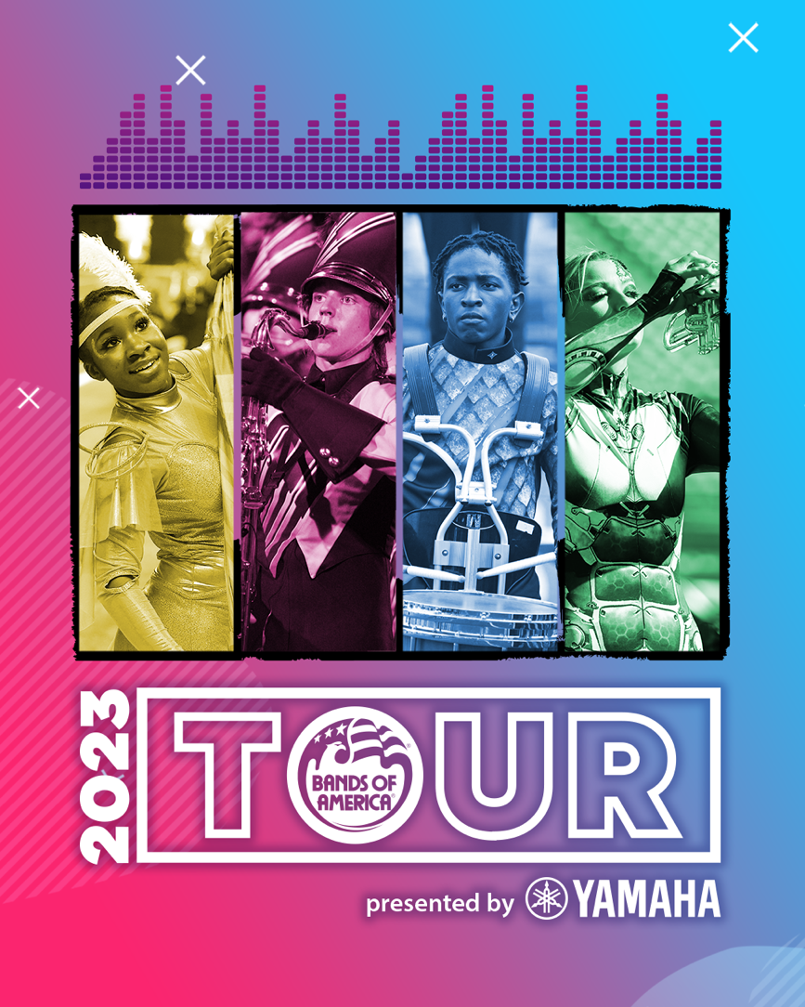
Can’t make it in person? All 2023 Bands of America Regional events will be livestreamed on BOALIVE.TV, powered by BOX5 Media. Viewers can choose pay-per-view to watch one event or select a subscription to watch the season.

To check scores and see photos from the events, follow Music for All on social media. You can also search #BOA2023 for the latest postings.

###

About Music for All
Music for All’s mission is to create, provide, and expand life-changing experiences through music. Our vision is to be a catalyst to ensure that every child in America has access and opportunity for active music-making in their scholastic environment. A 501(c)(3) nonprofit educational organization, Music for All’s events and programs serve more than 600,000 attendees annually –– more than 1.3 million since 1975. Programs include the Bands of America Championships for marching bands, a summer music camp for students and teachers, festivals for concert bands and orchestras, national honor ensembles for students, and educational webinars, podcasts, and online resources for teachers.
Music for All’s efforts are supported by national presenting sponsor Yamaha Corporation of America and its family of sponsors, strategic partners, and grantors.

Follow Us!

You can keep up with the latest information for Music for All online at musicforall.org, Facebook (@musicforallnetwork and @bandsofamerica,) Instagram (@officialmusicforall,) and TikTok (@officialmusicforall.)

Sponsor Information
Music for All efforts are supported through sponsorships, including current partnerships with National Presenting Sponsor: Yamaha Corporation of America; Official Uniform Sponsor: Fred J. Miller, Inc.; Official Student Travel Partner: Music Travel Consultants; Official Spirit Wear Sponsor: PepWear; Corporate Sponsors: Wenger Corporation, Ball State University, Visit Indy, and the City of Indianapolis; Associate Sponsors: REMO; StylePlus, and Bob Rogers Travel; and Summer Symposium event sponsor Cheddar Up. Music for All is also supported by the Indiana Arts Commission, a state agency, and the National Endowment for the Arts, a federal agency; the Arts Council of Indianapolis and the City of Indianapolis; Ball Brothers Foundation; Lilly Endowment Inc.; George and Frances Ball Foundation; Allen Whitehill Clowes Charitable Foundation, Inc. and Nicholas H. Noyes, Jr., Memorial Foundation, Inc.

Media Contact:
Mallory Duncan, Director of Marketing and Communications
Music for All
mallory.d@musicforall.org
Direct Phone: 317.524.6250

