Music for All Launches New Podcast Network
“Break Ranks” Returns September 13

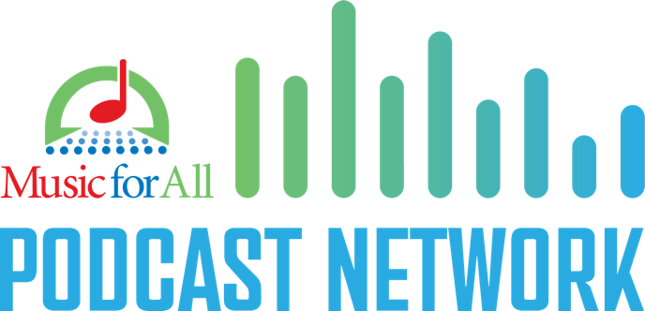
INDIANAPOLIS – Music for All is launching a new podcast network to continue its goal to provide high quality education and music opportunities for everyone.

The network will showcase a wide variety of podcasts, new and old, to bring focused content about music education and marching band events to teachers, parents, students, administrators, and more.

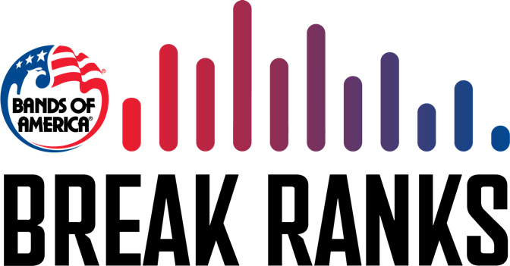
Leading the way, Music for All is bringing back the popular “Break Ranks” podcast. “Break Ranks,” hosted and produced by Bands of America’s Dan Potter, will return to bring you the latest about the Bands of America Championship season. Dan will explore every angle of marching band, with something for students, parents, teachers, administrators, and fans.

Look for “Break Ranks” every Wednesday this fall, starting September 13.

Other podcasts soon to join the network are Teaching Social Emotional Learning Through Music with Scott Edgar and David Duarte’s Culture Before Content.

Listen to Break Ranks and all of the Music for All Podcast Network on Spotify, Apple Podcasts, or wherever you listen to podcasts.

###

About Music for All
Music for All’s mission is to create, provide, and expand life-changing experiences through music. Our vision is to be a catalyst to ensure that every child in America has access and opportunity for active music-making in their scholastic environment. A 501(c)(3) nonprofit educational organization, Music for All’s events and programs serve more than 600,000 attendees annually –– more than 1.3 million since 1975. Programs include the Bands of America Championships for marching bands, a summer music camp for students and teachers, festivals for concert bands and orchestras, national honor ensembles for students, and educational webinars, podcasts, and online resources for teachers.
Music for All’s efforts are supported by national presenting sponsor Yamaha Corporation of America and its family of sponsors, strategic partners, and grantors.

Follow Us!

You can keep up with the latest information for Music for All online at musicforall.org, Facebook (@musicforallnetwork and @bandsofamerica,) Instagram (@officialmusicforall,) and TikTok (@officialmusicforall.)

Sponsor Information
Music for All efforts are supported through sponsorships, including current partnerships with National Presenting Sponsor: Yamaha Corporation of America; Official Uniform Sponsor: Fred J. Miller, Inc.; Official Student Travel Partner: Music Travel Consultants; Official Spirit Wear Sponsor: PepWear; Corporate Sponsors: Wenger Corporation, Ball State University, Visit Indy, and the City of Indianapolis; Associate Sponsors: REMO; StylePlus, and Bob Rogers Travel; and Summer Symposium event sponsor Cheddar Up. Music for All is also supported by the Indiana Arts Commission, a state agency, and the National Endowment for the Arts, a federal agency; the Arts Council of Indianapolis and the City of Indianapolis; Ball Brothers Foundation; Lilly Endowment Inc.; George and Frances Ball Foundation; Allen Whitehill Clowes Charitable Foundation, Inc. and Nicholas H. Noyes, Jr., Memorial Foundation, Inc.

Media Contact:
Mallory Duncan, Director of Marketing and Communications
Music for All
mallory.d@musicforall.org
Direct Phone: 317.524.6250

