Bands of America Tour Makes Stop in Memphis for the first time
24 high school marching bands will compete for the regional championship title Saturday

MEMPHIS, Tenn. - High School marching band students from across the region will perform at the first Bands of America Regional Championship in Memphis this weekend.

Bands will represent areas of Tennessee, Arkansas, Alabama, Kentucky, Missouri, Georgia, Mississippi and South Carolina at the 2023 Bands of America Memphis Regional Championship, presented by Yamaha, in the Simmons Bank Liberty Stadium.

For a look at the full schedule of bands, click here.

Bands will take the field beginning at 9:15 a.m. Doors will open to the public at 8:45 a.m. There will be a special exhibition performance by the University of Memphis Mighty Sound of the South at 4:30 p.m.

Twenty-four bands will compete in the premier marching band event that will feature live music, choreography and competition. They will be evaluated by a panel of nationally-recognized music educators and marching band experts. The top 12 scoring bands will advance to the evening finals where one band will be crowned champion at the end of the night.

The Bands of America Championships season will conclude with the Bands of America Grand National Championships Nov. 9-11 at Lucas Oil Stadium in Indianapolis, IN.

Tickets

Tickets will now be cashless for 2023. You can skip the line and buy tickets online for a reduced price here.

Check out the website for full ticket options, including full day passes, just tickets for finals and a group ticket option.

Children 10 years or younger are admitted for free for general admission seating.

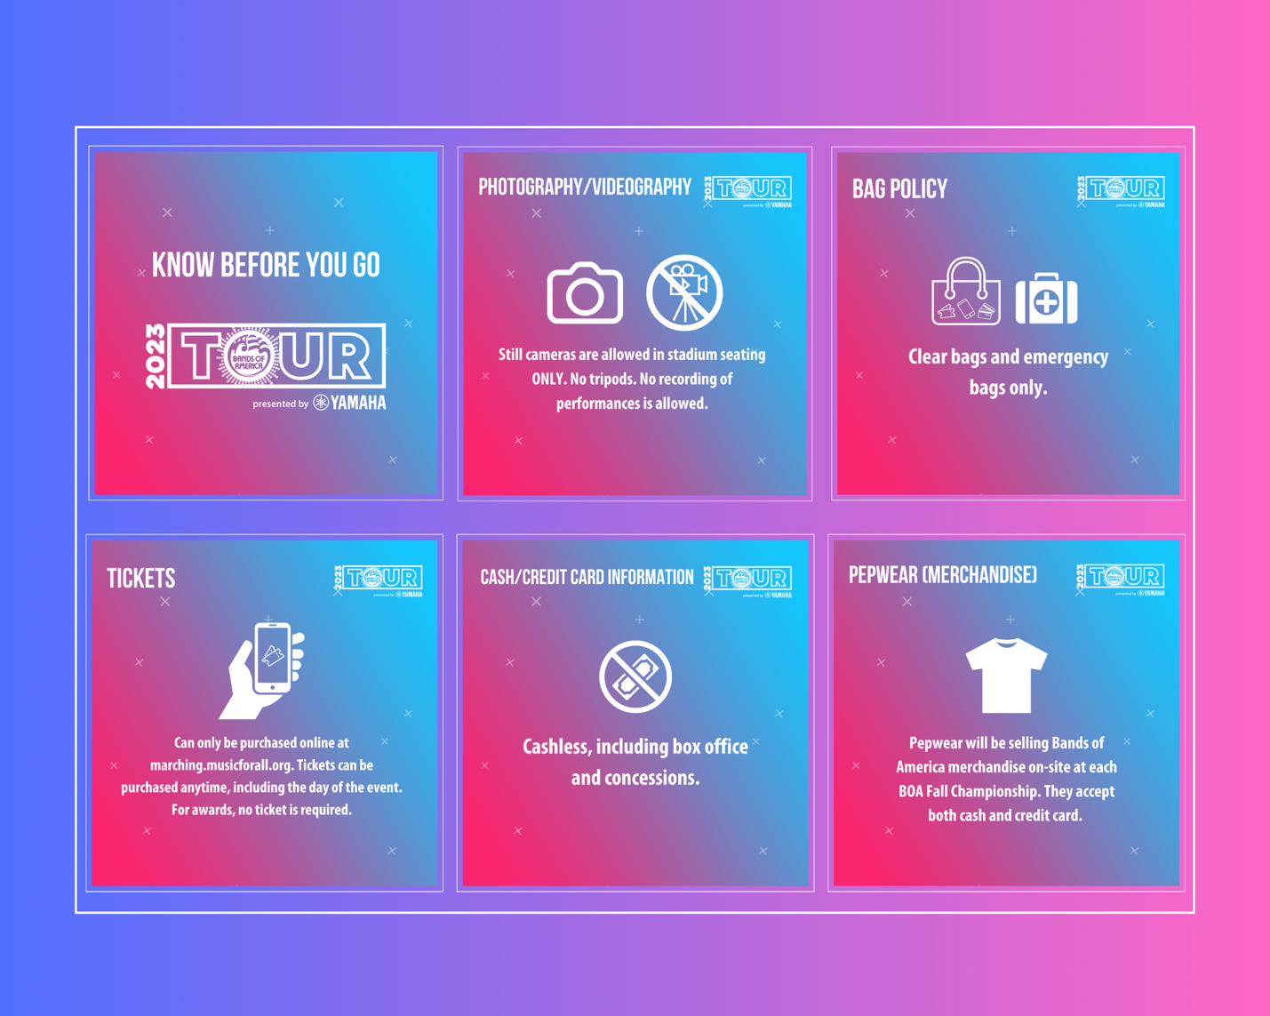
###

About Music for All
Music for All’s mission is to create, provide, and expand life-changing experiences through music. Our vision is to be a catalyst to ensure that every child in America has access and opportunity for active music-making in their scholastic environment. A 501(c)(3) nonprofit educational organization, Music for All’s events and programs serve more than 600,000 attendees annually –– more than 1.3 million since 1975. Programs include the Bands of America Championships for marching bands, a summer music camp for students and teachers, festivals for concert bands and orchestras, national honor ensembles for students, and educational webinars, podcasts, and online resources for teachers.
Music for All’s efforts are supported by national presenting sponsor Yamaha Corporation of America and its family of sponsors, strategic partners, and grantors.

Follow Us!
You can keep up with the latest information for Music for All online at musicforall.org, Facebook (@musicforallnetwork and @bandsofamerica,) Instagram (@officialmusicforall,) and TikTok (@officialmusicforall.)

Sponsor Information
Music for All efforts are supported through sponsorships, including current partnerships with National Presenting Sponsor: Yamaha Corporation of America; Official Uniform Sponsor: Fred J. Miller, Inc.; Official Student Travel Partner: Music Travel Consultants; Official Spirit Wear Sponsor: PepWear; Corporate Sponsors: Wenger Corporation, Ball State University, Visit Indy, and the City of Indianapolis; Associate Sponsors: REMO; StylePlus, and Bob Rogers Travel; and Summer Symposium event sponsor Cheddar Up. Music for All is also supported by the Indiana Arts Commission, a state agency, and the National Endowment for the Arts, a federal agency; the Arts Council of Indianapolis and the City of Indianapolis; Ball Brothers Foundation; Lilly Endowment Inc.; George and Frances Ball Foundation; Allen Whitehill Clowes Charitable Foundation, Inc. and Nicholas H. Noyes, Jr., Memorial Foundation, Inc.

Media Contact:
Mallory Duncan, Director of Marketing and Communications
Music for All
mallory.d@musicforall.org
Direct Phone: 317.524.6250

