Thousands of High School Students to Compete at Grand National Championships in Indianapolis
Nationwide High School Marching Band competition will take place in Lucas Oil Stadium November 9-11

INDIANAPOLIS – High school marching bands from across the nation will converge in Indianapolis to compete in the 2023 Bands of America Grand National Championships, presented by Yamaha, November 9-11.

More than 90 bands and close to 15,000 high school students will perform and represent 18 states including: Indiana, Ohio, Kentucky, West Virginia, Michigan, Illinois, Georgia, Texas, Pennsylvania, South Carolina, North Carolina, Nevada, Missouri, Arizona, Massachusetts, Tennessee, Kansas and Virginia.

For a look at the preliminary schedule of bands, click here.

The Bands of America (BOA) Grand National Championships will feature 93 high school marching bands in two days of preliminary competition. A panel of nationally recognized music educators and marching band experts will evaluate the bands. Up to 38 bands will advance to Saturday's Semi-Finals competition. The top 12 scoring bands will advance to Saturday evening's Finals competition.

Competition Schedule

Thursday, November 9
Prelims
- First band performance: 8:15 a.m.
- Gates open at 7:45 a.m.
- Special Indianapolis Public Music Showcase at 11:15 a.m.

Friday, November 10
Prelims
- First band performance: 8 a.m.
- Gates open at 7:30 a.m. (this says 6:30 in the schedule, is that correct??)

Saturday, November 11
Semi-Finals
- Semi-Finals start time will be determined Friday night after preliminary competition
Finals
- Gates open at 6:30 p.m.
- Finals special presentations start at 7 p.m.
- First finalist band takes the field at 8 p.m.

There will be special exhibition performances throughout the event by the Indiana University Marching Hundred, North Carolina A&T State University Blue & Gold Marching Machine and the University of Alabama Million Dollar Band.

Indianapolis band, orchestra, and choir students from Arsenal Technical High School, Crispus Attucks High School, George Washington High School, and Shortridge High School will perform together in special exhibition as the Indianapolis Public Schools Music Showcase on Thursday, Nov. 9 at 11:15 a.m. during the Grand Nationals Prelims.

Grand Nationals features an Expo in Lucas Oil Stadium for spectators and performers, as well as the Future Music Educators Experience for more than 200 college music majors.

“Music for All is about building leaders and celebrating teachers. The Bands of America Grand National Championships in Indianapolis is a celebration of music education at its finest, showcasing the excellence, teamwork, and student leadership of the nation’s outstanding marching bands,” said Jeremy L. Earnhart, President and CEO of Music for All, the non-profit educational organization that presents Bands of America programs. “These young performers and their achievements advocate for the importance of music education in schools locally and nationwide.”

Tickets

Tickets will now be cashless for 2023. You can skip the line and buy tickets online for Thursday Prelims, Friday Prelims, Saturday Semi-Finals and Saturday Finals.

Check out the website for full ticket options, including full day passes, just tickets for finals and a group ticket option.

Children 10 years or younger are admitted for free for general admission seating.

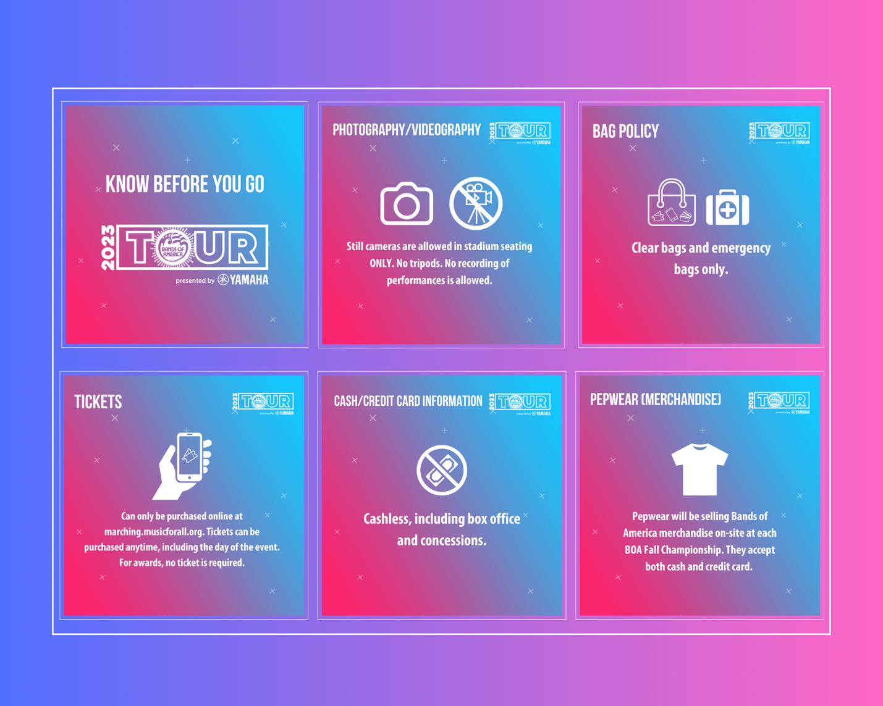
###

About Music for All
Music for All’s mission is to create, provide, and expand life-changing experiences through music. Our vision is to be a catalyst to ensure that every child in America has access and opportunity for active music-making in their scholastic environment. A 501(c)(3) nonprofit educational organization, Music for All’s events and programs serve more than 600,000 attendees annually –– more than 1.3 million since 1975. Programs include the Bands of America Championships for marching bands, a summer music camp for students and teachers, festivals for concert bands and orchestras, national honor ensembles for students, and educational webinars, podcasts, and online resources for teachers.
Music for All’s efforts are supported by national presenting sponsor Yamaha Corporation of America and its family of sponsors, strategic partners, and grantors.

Follow Us!
You can keep up with the latest information for Music for All online at musicforall.org, Facebook (@musicforallnetwork and @bandsofamerica,) Instagram (@officialmusicforall,) and TikTok (@officialmusicforall.)

Sponsor Information
Music for All efforts are supported through sponsorships, including current partnerships with National Presenting Sponsor: Yamaha Corporation of America; Official Uniform Sponsor: Fred J. Miller, Inc.; Official Student Travel Partner: Music Travel Consultants; Official Spirit Wear Sponsor: PepWear; Corporate Sponsors: Wenger Corporation, Ball State University, Visit Indy, and the City of Indianapolis; Associate Sponsor: StylePlus. Music for All is also supported by the Arts Council of Indianapolis and the City of Indianapolis; Ball Brothers Foundation; Lilly Endowment Inc.; George and Frances Ball Foundation; Allen Whitehill Clowes Charitable Foundation, Inc., Nicholas H. Noyes, Jr., Memorial Foundation, Inc, and the Arthur Jordan Foundation.

Media Contact:
Mallory Duncan, Director of Marketing and Communications
Music for All
mallory.d@musicforall.org
Direct Phone: 317.524.6244

