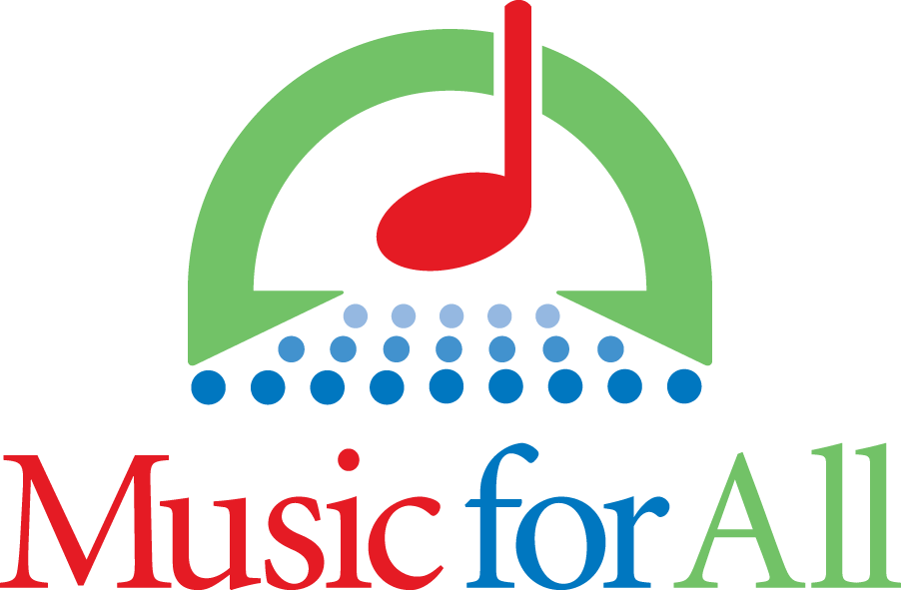  
**Music for All Names 2025 Advocacy in**

**Action Recipients**

INDIANAPOLIS, IN – Music for All has announced the recipients of the 2025 Advocacy in Action Awards. These awards highlight educators and programs that have created an event or idea that is exceptional in their field and community.

The Advocacy in Action awards are presented each year in seven categories: Community Involvement, Decision-Maker Engagement, Elementary Excellence, Innovative Fundraising, Marketing and Promotion, Parent/Booster Support, and Student Recruitment, Engagement, and Retention.

The recipients will be featured on Music for All’s Advocacy in Action Archive, where their ideas will be available for music educators across the country to learn from and emulate.

The Advocacy in Action Awards recognize and celebrate the commitment of school administrators, community leaders, teachers and parents who believe in music education and are advocating to ensure that it is part of a comprehensive education for all children.

Advocacy in Action is a signature program of Music for All designed to collect, recognize, and share effective practices and initiatives that support music education in our schools.

For more on the Advocacy in Action program, or to view the archive, please head to advocacy.musicforall.org.

For graphics of all winners, click [here](https://www.dropbox.com/scl/fo/8q7sivop71qzvbhtm6sa6/AMD-kKOvk6uduuR7zM5GCJo?rlkey=ndc8sfhzsjiymou03v3jjhcgp&st=jf0j18wz&dl=0).

###

**About Music for All**

Music for All’s mission is to create, provide, and expand life-changing experiences through music. Our vision is to be a catalyst to ensure that every child in America has access and opportunity for active music-making in their scholastic environment. A 501(c)(3) nonprofit educational organization, Music for All’s events and programs serve more than 600,000 attendees annually –– and more than 1.7 million program participants since 1975. Programs include the Bands of America Championships for marching bands, a summer music camp for students and teachers, festivals for concert bands and orchestras, national honor ensembles for students, and educational webinars, podcasts, and online resources for teachers.

Music for All’s efforts are supported by national presenting sponsor Yamaha Corporation of America and its family of sponsors, strategic partners, and grantors.

**Follow Us!**

You can keep up with the latest information for Music for All online at musicforall.org, Facebook (@musicforallnetwork and @bandsofamerica,) Instagram (@officialmusicforall,) and TikTok (@officialmusicforall.)

**Sponsor Information**

Music for All efforts are supported through sponsorships, including current partnerships with National Presenting Sponsor: Yamaha Corporation of America; Official Instrument Rental Partner: Sweetwater; Official Uniform Sponsor: Fred J. Miller, Inc.; Official Student Travel Partner: Music Travel Consultants; Official Spirit Wear Sponsor: PepWear; Corporate Sponsors: Ball State University and Visit Indy; and Associate Sponsor: StylePlus. Music for All is also supported by the Arts Council of Indianapolis and the City of Indianapolis; Ball Brothers Foundation; Lilly Endowment Inc.; George and Frances Ball Foundation; Allen Whitehill Clowes Charitable Foundation, Inc., Nicholas H. Noyes, Jr., Memorial Foundation, Inc, and the Arthur Jordan Foundation.

**Media Contact:**

Rachel Puckett, Promotions Senior Coordinator

Music for All

rachel.p@musicforall.org

Direct Phone: 317.218.4894