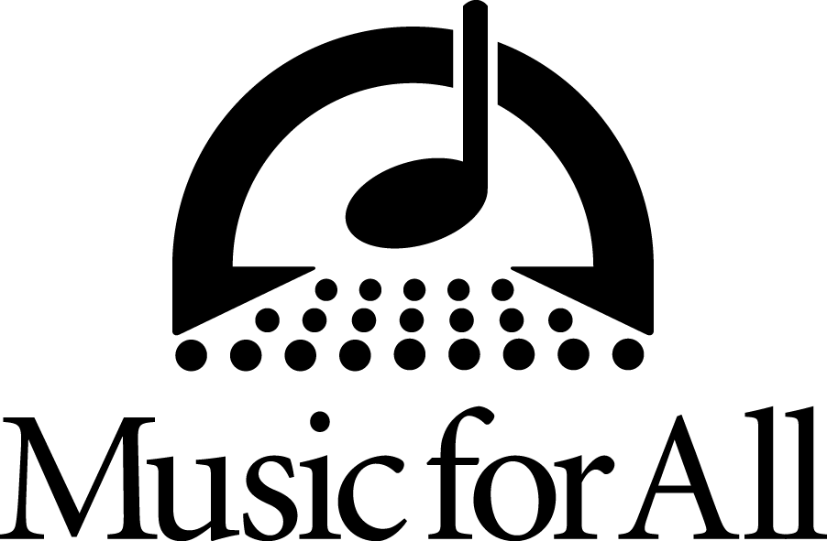

**Music for All Announces the 2026 Hall of Fame Inductees**

INDIANAPOLIS – Music for All announces the 2026 Hall of Fame inductees, Jay Bocook, Mike Davis, Susan L. Smith, and W. Dale Warren.

Music for All’s Hall of Fame recognizes individuals who have significantly impacted Music for All, its programs, and music education in America. Members represent impeccable character, ethics, and professionalism, and are role models for music education professionals.

Bocook, Davis, Smith, and Warren will be inducted during a ceremony at the 2026 Music for All National Festival, presented by Yamaha, March 26-28 in Indianapolis, IN.

**About the inductees:**

**Jay Bocook**

Jay Bocook is internationally recognized as an educator, conductor, composer, and GRAMMY- nominated arranger.

He is known in Music for All’s history as being an integral part of the Marching Bands of America Summer Workshop/Festival in Whitewater, WI. Bocook continued to support the organization as it became Bands of America and has grown into what it is today.

Bocook's works have been performed at the 1984 Olympic Games in Los Angeles, the 1996 Centennial Olympic Games in Atlanta, and the 2002 Winter Olympics in Salt Lake City. He was a contributing arranger in the musical “CyberJam” and principal arranger and Associate Music Director for “Blast!, The Music of Disney.” His arrangements are performed by bands, drum corps, and the prestigious “The President’s Own.”

**Mike Davis**

Mike Davis supported Marching Bands of America (MBA) by bringing the organization to the University of Wisconsin-Whitewater starting in 1976. He then joined the MBA advisory board in 1979 and continued to support by hosting the first regional championship and championing the organization throughout his career.

Davis retired as the band and orchestra director for the Walt Disney World Resort in 2001. During his tenure with Walt Disney World, he conducted the Walt Disney World Band and Orchestra in the Magic Kingdom and EPCOT Center for the Candlelight Procession. He also appeared on national TV specials as the personality “Major Mike”, as well as conducted the music for the inauguration of three Presidents of the United States.

Davis's career has taken him to Paris and Tokyo with Disney, but prior to that he taught at James Madison University, the University of Wisconsin, Whitewater, as well as teaching high school, middle school, and elementary in Illinois and Wisconsin.

After retiring from the Walt Disney Company, Mike served as the Executive Director of a professional non-profit ensemble, the St. Johns River City Band in Jacksonville, Florida. In 2004, Michael conducted the Jacksonville Youth Symphony Orchestra along with the Jacksonville Children’s Chorus and 2,300 students for Jacksonville, Florida in the national PBS special, “The Worlds Largest Concert” that aired to over ten million viewers. In the same year, Davis received the Lowell Manson Fellow Award from the National Association of Music Education for significant contributions to music education in America.

**Susan L. Smith**

Susan L. Smith has been heavily involved in Music for All programing as a camp SWAG (counselor), camp faculty, Music for All National Festival Student Workshop Coordinator, former Chamber Music Festival Coordinator, former Bands of America participating director, Music for All Educational Advisor, co-founder of the *Mind the Gap* podcast, and Bands of America adjudicator.

Smith is currently the Southern Division President of the National Association of Music Education She most recently was the Associate Conductor of the Alabama Winds and Education Coordinator for the Madison Scouts Drum and Bugle Corps. Her previous appointment was as an Assistant Professor of Music Education at Troy University and Director of Bands at the Saint James School in Montgomery, AL. She is the Past President of the Alabama Music Educators Association and faculty advisor for the Troy Collegiate NAfME Chapter.

Smith has presented clinics at many regional, state, and national NAfME conferences. She has also presented at the Midwest Clinic multiple times and performed as a member of the Alabama Winds, an adult community band comprised of Alabama music educators. Her professional affiliations include Phi Beta Mu, National Association for Music Education, Sigma Alpha Iota, Phi Beta Kappa and the National Band Association.

In September 2023, Smith became President and CEO of the RWS Music Publishing Company after the sudden passing of her husband of 30 years, composer and educator, Robert W. Smith. Susan is committed to honoring the legacy of her late husband and continuing his goal of providing quality music curriculum materials for teachers and students and supporting the development of emerging young writers.

**W. Dale Warren**

W. Dale Warren is Senior Wind Band Conductor and Professor of Music in the University of Arkansas’ Department of Music, where he has served three-plus decades teaching music education courses and conducting the ensembles.

Warren has served as a member of Music for All’s Educational Advisory Board and for the past 36 years as an adjudicator and chief judge for Bands of America.

Warren previously taught at Kentucky high schools Bremen and North Hardin where the bands received numerous awards and Division I ratings. He has guest conducted all-district, all-region, and all-state honor bands as well as university bands in 39 states. He also serves as chairman of the John Philip Sousa Foundation’s Sudler Sheild Award Committee as a John Philip Sousa Foundation Board Member.

*To read more about the Music for All Hall of Fame and read about past inductees, visit musicforall.org*

**###**

**About Music for All**

Music for All’s mission is to create, provide, and expand positively life-changing experiences through music. Our vision is to be a catalyst to ensure that every child in America has access and opportunity for active music-making in their scholastic environment. A 501(c)(3) nonprofit educational organization, Music for All’s events and programs serve more than 600,000 attendees annually –– and more than 1.7 million program participants since 1975. Programs include the Bands of America Regional and the Grand National Championships for marching bands; the Bands of America Summer Camp for students and teachers; the Music for All National Festival for concert bands, orchestras, and percussion ensembles; national honor ensembles including the Honor Band of America, Jazz Band of America, and the Honor Band in the Rose Parade®, Advocacy in Action Awards, the Music for All Podcast Network, and affiliate concert and marching events across America. Visit musicforall.org

Music for All’s efforts are supported by national presenting sponsor Yamaha Corporation of America and its family of sponsors, strategic partners, and grantors.

**Follow Us!**

You can keep up with the latest information for Music for All online at musicforall.org, Facebook (@musicforallnetwork and @bandsofamerica,) Instagram (@officialmusicforall,) and TikTok (@officialmusicforall.)

**Sponsor Information**

Music for All efforts are supported through sponsorships, including current partnerships with National Presenting Sponsor: Yamaha Corporation of America; Official Instrument Rental Partner: Sweetwater; Official Uniform Sponsor: Fred J. Miller, Inc.; Official Student Travel Partner: Music Travel Consultants; Official Spirit Wear Sponsor: PepWear; Corporate Sponsors: Ball State University and Visit Indy; and Associate Sponsor: StylePlus. Music for All is also supported by the Arts Council of Indianapolis and the City of Indianapolis; Ball Brothers Foundation; Lilly Endowment Inc.; George and Frances Ball Foundation; Allen Whitehill Clowes Charitable Foundation, Inc., Nicholas H. Noyes, Jr., Memorial Foundation, Inc, the Arthur Jordan Foundation, The Indiana Arts Commission, and The NAMM Foundation.

**Media Contact:**

Rachel Puckett, Promotions Senior Coordinator

Music for All

[rachel.p@musicforall.org](mailto:rachel.p@musicforall.org)