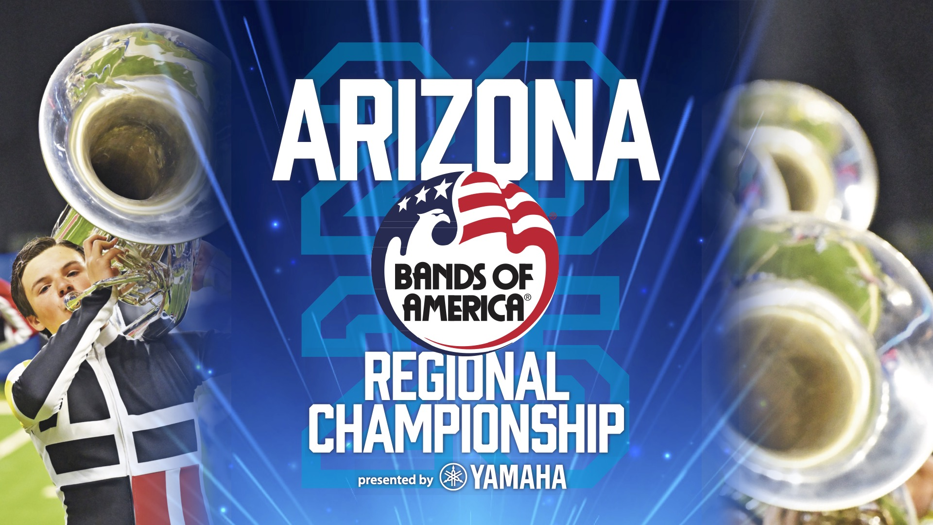

2025 Bands of America Regional Championship is in Flagstaff, Arizona, on Sept. 27.

*24 high school marching bands will compete for the regional championship title*

FLAGSTAFF, ARIZONA- High School marching band students from across the region will perform at the Bands of America Arizona Regional, presented by Yamaha, Saturday, Sept. 27 at J. Lawrence Walkup Skydome at Northern Arizona University.

Bands from Arizona, California, Nevada, New Mexico, Oklahoma, Texas, and Utah will compete. Bands of America Championships are the nation’s premier marching band events, showcasing outstanding student musicians and visual performances.

This event is hosted by NAU Lumberjack Marching Band.

There will be an exhibition performance by the Northern Arizona University Lumberjack Marching Band following the conclusion of the preliminary competition at 4:15 p.m.

For a look at the full schedule of bands, [visit marching.musicforall.org.](https://marching.musicforall.org/2025schedule/)

Bands take the field for preliminary competition performances at 8:45 a.m. Gates will open to the public at 8:15 a.m. Times are subject to change, visit marching.musicforall.org for the latest event schedule.

Performances will be evaluated by a panel of nationally recognized music educators and marching band experts. The 12 highest-scoring bands will advance to the evening finals with the top-scoring band named champion at the end of the night. The first competing finalist band is at 7:30 p.m. with gates opening at 6:30 p.m.

The 2025 Bands of America Championships season includes 29 events across America, culminating with the Bands of America Grand National Championships at Lucas Oil Stadium in Indianapolis, November 13-15.

Music for All is celebrating its 50th anniversary this season. Since 1975, Bands of America has supported music education and the marching arts. This year, the organization celebrates all the bands who have stepped foot on a marching field and create the path for all who will come. For more information, visit [musicforall.org/50](https://musicforall.org/50)

**Tickets**

All tickets are digital, and the event is cashless. You can skip the line and buy tickets online at [marching.musicforall.org](https://marching.musicforall.org).

Check out the website marching.musicforall.org/boa for all ticket options, including full day passes, tickets for finals and student group tickets, as well as stadium policies to know before you go.

Children 10 years or younger are admitted for free for general admission seating.

###

**About Music for All**

Music for All’s mission is to create, provide, and expand positively life-changing experiences through music. Our vision is to be a catalyst to ensure that every child in America has access and opportunity for active music-making in their scholastic environment. A 501(c)(3) nonprofit educational organization, Music for All’s events and programs serve more than 600,000 attendees annually –– and more than 1.7 million program participants since 1975. Programs include the Bands of America Regional and the Grand National Championships for marching bands; the Bands of America Summer Camp for students and teachers; the Music for All National Festival for concert bands, orchestras, and percussion ensembles; national honor ensembles including the Honor Band of America, Jazz Band of America, and the Honor Band in the Rose Parade®, Advocacy in Action Awards, the Music for All Podcast Network, and affiliate concert and marching events across America. Visit musicforall.org

Music for All’s efforts are supported by national presenting sponsor Yamaha Corporation of America and its family of sponsors, strategic partners, and grantmaking foundations.

**Follow Us!**

You can keep up with the latest information for Music for All online at musicforall.org, Facebook (@musicforallnetwork and @bandsofamerica,) Instagram (@officialmusicforall,) and TikTok (@officialmusicforall.)

**Sponsor Information**

Music for All efforts are supported through sponsorships, including current partnerships with National Presenting Sponsor: Yamaha Corporation of America; Official Instrument Rental Partner: Sweetwater; Official Uniform Sponsor: Fred J. Miller, Inc.; Official Student Travel Partner: Music Travel Consultants; Official Spirit Wear Sponsor: PepWear; Corporate Sponsors: Ball State University and Visit Indy; and Associate Sponsor: StylePlus; and Event Sponsors: US Army ROTC and US Marines. Music for All is also supported by Indy Arts Council and the City of Indianapolis; Ball Brothers Foundation; Lilly Endowment Inc.; George and Frances Ball Foundation; Allen Whitehill Clowes Charitable Foundation, Inc., Nicholas H. Noyes, Jr., Memorial Foundation, Inc., the NAMM Foundation, and the National Bank of Indianapolis.

**Media Contact:**

Rachel Puckett, Promotions Senior Coordinator

Music for All

[rachel.p@musicforall.org](mailto:rachel.p@musicforall.org)

Direct Phone: 317.218.4894