FOR IMMEDIATE RELEASE

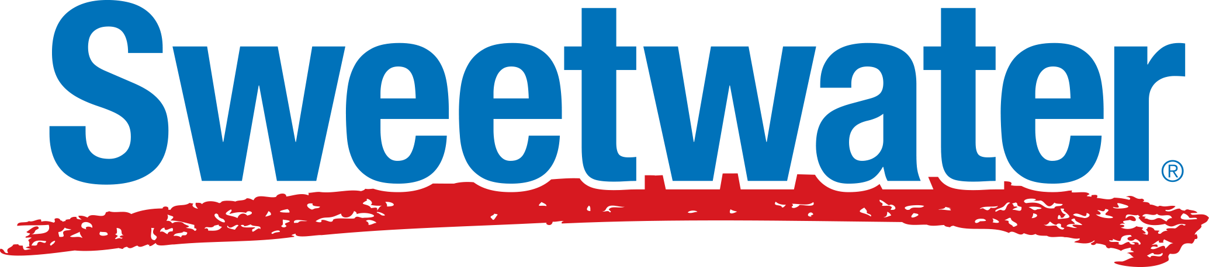
Sweetwater Named National Presenting Sponsor of Music for All
INDIANAPOLIS, Ind. – May 2026 – Music for All has announced Sweetwater as a National Presenting Sponsor, marking a major expansion of the organizations’ shared commitment to strengthening music education opportunities for students and educators nationwide. The partnership will help broaden access to active music-making experiences, provide greater support and resources for teachers, and invest in the future of scholastic music programs across America.
Sweetwater, the largest online retailer of musical instruments and audio equipment in the U.S., serving millions of customers, was previously Official Instrument Rental Partner of Music for All and now joins Yamaha Corporation of America at the National Presenting Sponsor level.
These powerhouses in the music industry are teaming up to provide and invest in educational opportunities for more people than ever before. Through the sponsorship, Sweetwater will help Music for All continue delivering nationally recognized educational experiences that reach hundreds of thousands of students, educators, and families annually.
Support from the partnership will strengthen programming, enhance educational resources, and help remove barriers to participation for schools and students across the country.
“This increased and deepening partnership with Sweetwater represents a significant step forward in our mission to create, provide, and expand life-changing experiences through music,” says Music for All CEO and President, James Weaver. “Their commitment to supporting educators and students aligns directly with our vision for the future of music education. Together, we are not just sustaining programs, we are accelerating access, innovation, and impact for music makers across the country.”
Jeremy Mueller, Sweetwater VP Institutional Sales, Rentals, and Lessons, adds, “We continue to feel a deep responsibility to support school music programs through the work we do with Music for All. By expanding this partnership, we're putting better tools, better training, and better resources in the hands of music educators nationwide — because the skills and experiences students gain in those programs stick with them for life. That matters to us.”
The expanded partnership reflects both organizations' long-term commitment to strengthening impact for students and educators nationwide through life-changing, transformative music education experiences.
Sweetwater’s national presenting sponsorship supports Music for All’s programs including the Bands of America Championships, the Music for All National Festival, Music for All Summer Camp, and Music for All’s educational outreach and advocacy efforts.
For more information about Music for All, visit musicforall.org, and for Sweetwater, visit sweetwater.com.
###
About Music for All
Music for All’s mission is to create, provide, and expand positively life-changing experiences through music. Our vision is to be a catalyst to ensure that every child in America has access and opportunity for active music-making in their scholastic environment. A 501(c)(3) nonprofit educational organization, Music for All’s events and programs serve more than 600,000 attendees annually –– and more than 1.7 million program participants since 1975. Programs include the Bands of America Regional and the Grand National Championships for marching bands; the Bands of America Summer Camp for students and teachers; the Music for All National Festival for concert bands, orchestras, and percussion ensembles; national honor ensembles including the Honor Band of America, Jazz Band of America, and the Honor Band in the Rose Parade®, Advocacy in Action Awards, the Music for All Podcast Network, and affiliate concert and marching events across America. Follow Us! You can keep up with the latest information for Music for All online at musicforall.org, Facebook (@musicforallnetwork and @bandsofamerica,) Instagram (@officialmusicforall,) and TikTok (@officialmusicforall.)

About Sweetwater
The No. 1 online retailer for music makers, Sweetwater is trusted and beloved by
millions of musicians, sound engineers, band and orchestra directors, and podcasters
who rely on the company to help advance their musical and creative journeys. From
beginners to rock stars, music makers everywhere seek out Sweetwater’s industry leading expertise, including in-depth product videos to inform their purchases, and
unrivaled post-care support. Headquartered in Fort Wayne, Ind., and founded in 1979,
Sweetwater credits its four decades of profitability to its now 3,000 employees and its
deep understanding of the profound connection that music makers have with their craft,
their gear and the creative process. Sweetwater views music as a force for good, with
philanthropic efforts focused on youth music education, bringing music to underserved
areas, and advancing musicians’ mental wellbeing. For more information, visit
Sweetwater.com.

Media Contact:
Rachel Puckett, Promotions Senior Coordinator, Music for All
rachel.p@musicforall.org | Direct Phone: 317-218-4894

